DATA ANALYTICS WITH TABLEAU

ASSIGNMENT – 1

N.Jasmine

VNITSW

B.Tech(CSE)-4

20NN1A0529

1.BAR CHART

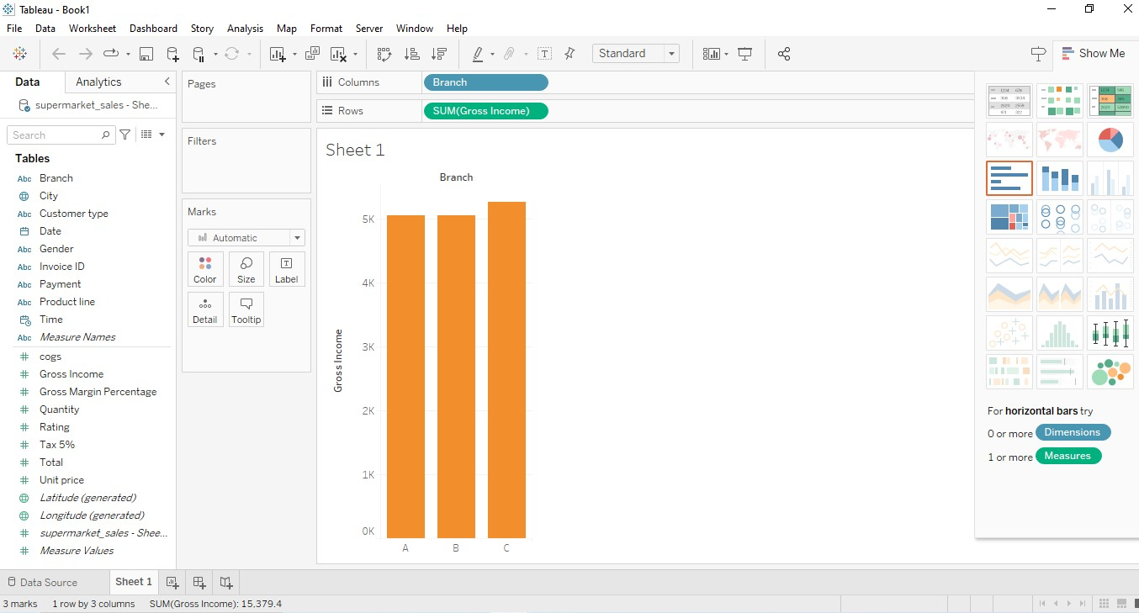

2.PIE CHART

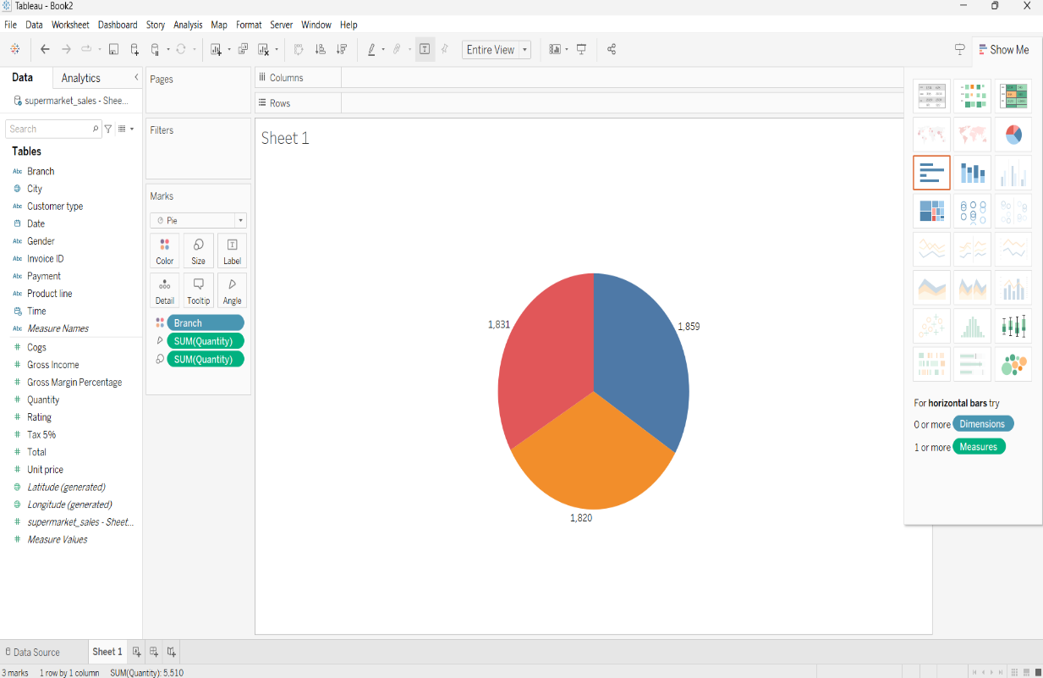

3.STACKED BAR CHART

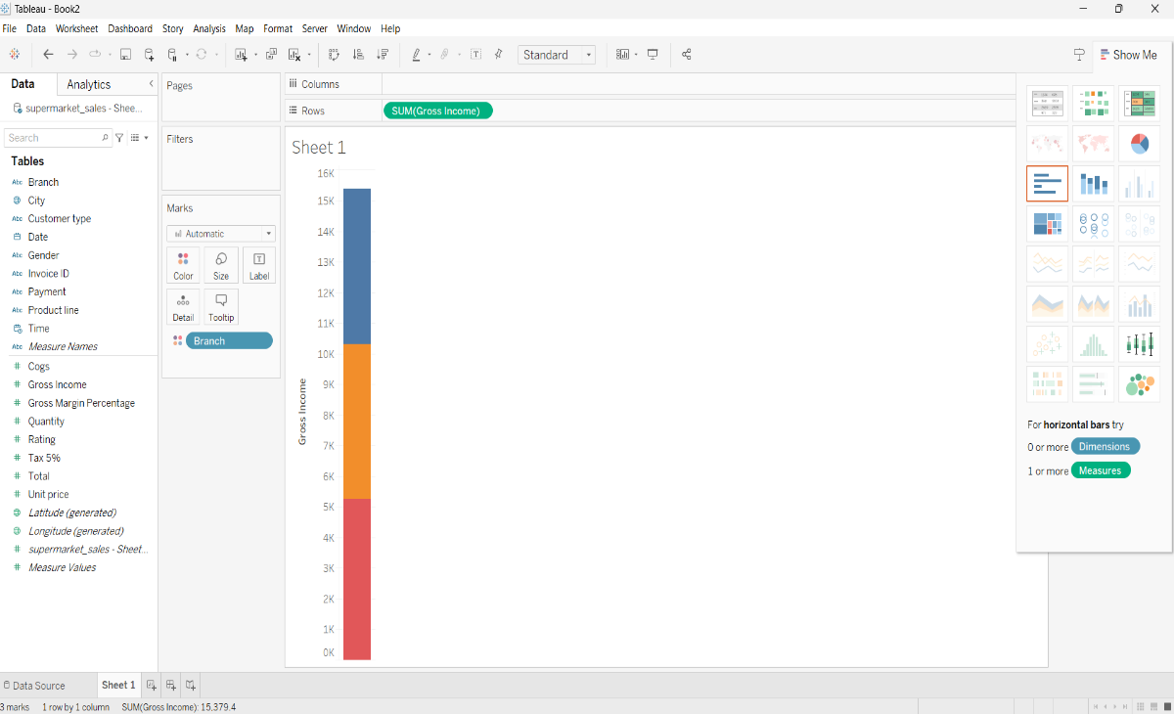

4.LINE CHART

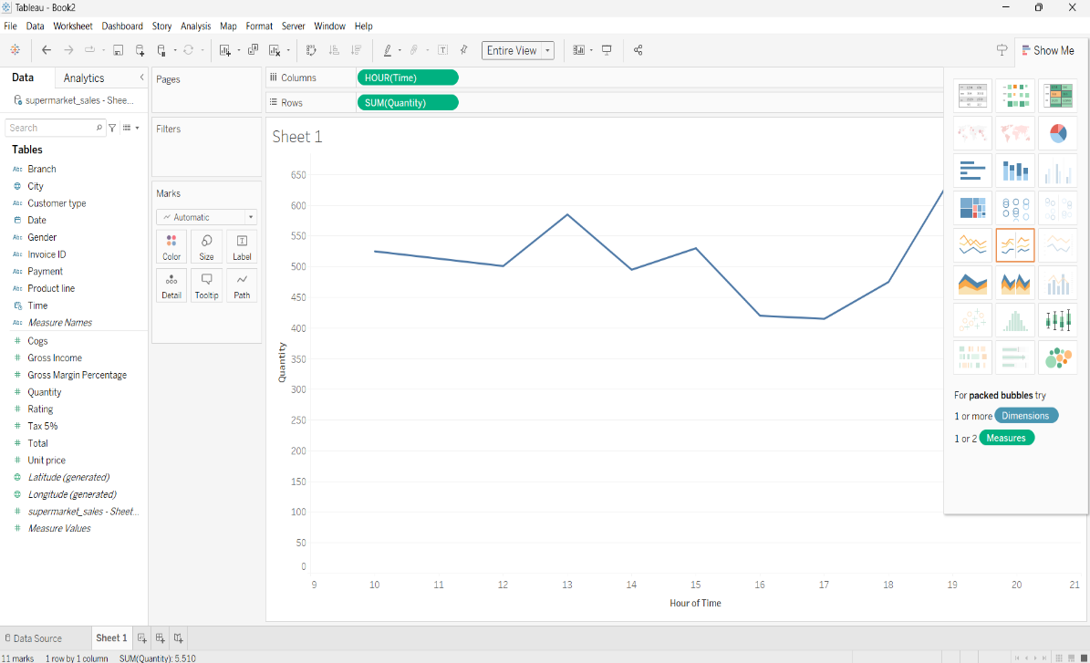

5.BUBBLE CHART

